Kerr solitons from a chirped background



**Letter**

Daniel C. Cole,1,2* Jordan R. Stone,1,2, Ki Youl Yang3, Xu Yi3, Kerry J. Vahala3, and Scott B. Papp1,2

1National Institute of Standards and Technology (NIST), Boulder, CO 80305, USA

2Department of Physics, University of Colorado, Boulder, CO 80309, USA

3T. J. Watson Laboratory of Applied Physics, California Institute of Technology, Pasadena, California 91125, USA

*Corresponding author: daniel.cole@nist.gov

Received XX Month XXXX; revised XX Month, XXXX; accepted XX Month XXXX; posted XX Month XXXX (Doc. ID XXXXX); published XX Month XXXX

We demonstrate protected single-soliton formation and operation in a Kerr ring resonator using a phase-modulated pump laser. Amplitude and phase variations in the resonator background induced by the phase modulation lead to the emergence of an operation regime in which degeneracy is lifted and the single soliton is the only behavior. Direct excitation of single solitons is indicated by observed reversal of the characteristic ‘soliton step.’ Phase modulation also enables precise control of the soliton pulse train’s properties, and measured dynamics agree closely with simulations. We show that the technique can be extended to high repetition-rate systems through subharmonic phase modulation. These results will facilitate straightforward generation and control of Kerr soliton microcombs in integrated photonics systems.

***OCIS codes:*** *(190.5530) Pulse propagation and temporal solitons; (140.3948) Microcavity devices*

<http://dx.doi.org/10.1364/optica.99.099999>

Dissipative cavity solitons in Kerr microresonators [1–3] have the potential to provide the revolutionary capabilities of frequency combs in a chip-integrable platform. This would extend the reach of frequency combs to applications in communications, computation, and sensing with low size, weight, and power. Progress has come rapidly in the field of microresonator-soliton-based frequency combs, but for these combs to reach applications, simple, repeatable, and platform-independent methods of soliton generation and control are needed. The basic challenge is that solitons in microresonators are independent excitations, and a resonator can host zero, one, or many co-circulating solitons at a given pump-laser power and frequency, with each soliton giving rise to its own out-coupled pulse train. Further, under normal conditions solitons can only be generated by condensation from extended modulation-instability (MI) patterns (primary comb/Turing patterns, or noisy comb/spatiotemporal chaos) that provide appropriate initial conditions. Thermal stability must be maintained during the drop in intracavity power associated with the transition from a high duty-cycle MI pattern to a low duty-cycle soliton. A variety of schemes have been demonstrated to address these challenges and obtain single solitons [4–7], and many achieve excellent performance. In general these schemes increase experimental complexity, exploiting non-adiabatic variations in pump-laser power and frequency, and involve at least some amount of stochastic fluctuation in the output from run to run.

One notable possibility is modulation of the pump laser at a frequency near the resonator free-spectral range (FSR) [8,9], which can enable deterministic condensation of either one or zero solitons from an MI pattern. Further, it has been demonstrated that phase modulation (PM) can facilitate generation of single solitons [10,11]. Here we use PM at the FSR to excite single solitons directly from a chirped background that is stable elsewhere. Exiting the resonator is a train of solitons spaced by the round-trip time, as shown in Fig. 1a. Importantly, no transient perturbation to the system parameters is required.

Our results demonstrate a regime in which single-soliton operation is fundamentally protected. We perform preliminary explorations of this regime using the Lugiato-Lefever equation (LLE) [1,10,12–14], as explained below. We find that the background chirp resulting from PM transforms the resonator excitation spectrum, shown in Fig. 1b, from a series of $N=0, 1, 2,…,N_{max}$ solitons to a single level $N=1$ near the four-wave mixing (FWM) threshold, eliminating degeneracy between these states. This occurs due to amplitude variations resulting from the background chirp, with dispersion and nonlinearity providing the PM-to-AM conversion. The background intensity acquires two peaks per round trip, as shown in Fig. 1c. Near threshold, the larger peak becomes locally unstable, and a soliton forms. Moreover, if solitons do exist elsewhere, they are pushed towards the larger intensity peak by the background’s modulated phase [15]. This makes superpositions of $N>1$ solitons unstable and practically forbidden. Generation of single solitons then simply requires tuning the pump power and frequency to appropriate values, regardless of initial conditions.

We generate solitons in a 22 GHz-FSR ring resonator with $Δf\sim$ 1.5 MHz linewidth [16], using a laser that is modulated at a rate $f_{PM}$ near 22 GHz with relatively small depth $δ_{PM}≈π$, and that has power ~2-6 times the absolute FWM threshold. We overcome thermal instabilities [17] and control the detuning $σ=f_{pump}-f_{res}$ in real time using a frequency-agile pump [18], with an AOM-shifted probe that enables continuous monitoring of $σ$. We increase $σ$ from large negative detuning ($σ\sim -$ 40 MHz), and a soliton is generated near $σ=-$ 5 MHz (the exact detuning is dependent upon the pump power and the coupling condition). Measuring the power converted through FWM to new frequencies, the ‘comb power,’ reveals a step upon soliton

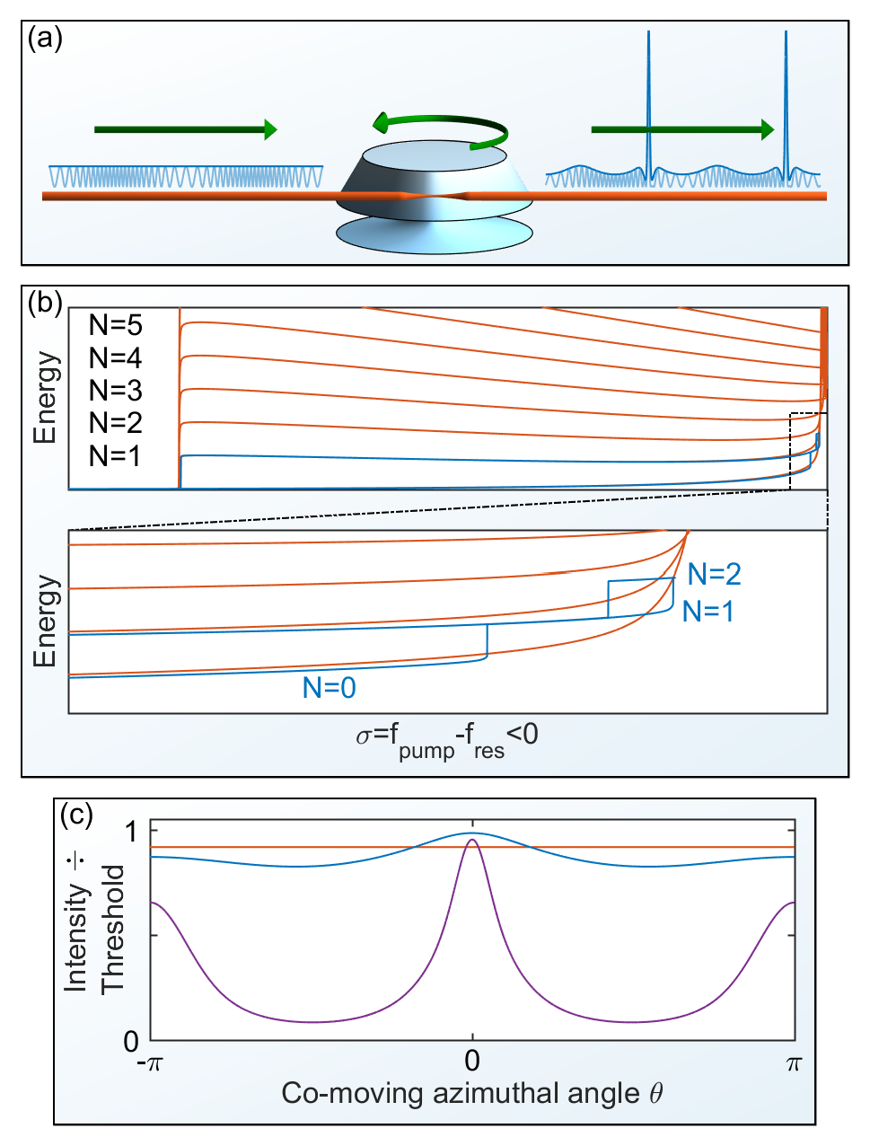

Fig 1. (a) Schematic for soliton generation in a PM-pumped resonator (neglecting interference of the out-coupled pulse train with transmitted pump light). (b) Simulated energy-level diagrams for the c.w.- (orange) and PM-pumped (blue) resonator. In the presence of PM, an interval in $σ$ exists for which the single soliton is the only available energy level. For smaller $|σ|$ (higher laser frequency), a soliton also forms at the smaller intensity peak, but this second soliton vanishes if $|σ|$ is subsequently increased. For $\left|σ\right|$ smaller than the band over which $N=2$ is possible, the state becomes non-stationary and the energy is ill-defined. (c) Simulated intensity of the background in the resonator without (orange) and with PM of depth $π/2$ (blue) and $6π$ (purple). Here $Δ$ is slightly less than the critical value for soliton formation.

formation, shown in Fig. 2a. This represents a reversal of the characteristic ‘soliton step’ that typically signals condensation of solitons from an extended pattern and indicates direct generation of a soliton from the background. After soliton generation, $σ$ may be decreased again without loss of the soliton, consistent with Fig. 1b. We have verified that it is possible to turn off the PM while preserving the soliton (see also Ref.  [10]).

Automating soliton generation by repeatedly scanning the laser into resonance ($σ\sim -$ 5 MHz) and back out again ($σ\sim -$ 20 MHz, far enough that the soliton is lost) has enabled reversible generation of 1000 solitons in 1000 trials over 100 seconds, with a 100 % measured success rate. Our $σ$-locking scheme enables measurement of the detuning at which soliton generation occurs, which changes little from run to run. Fig. 1e presents a histogram of measurements for the generation of 160 solitons.

Besides enabling protected single-soliton operation, PM-pumping also naturally provides timing and repetition-rate control, because the solitons are pushed towards the larger background peak. This is illustrated in Fig. 2. In our experiments, the repetition rate of the out- coupled pulse train ( $f_{rep})$ remains locked to $f_{PM}$ over a bandwidth of

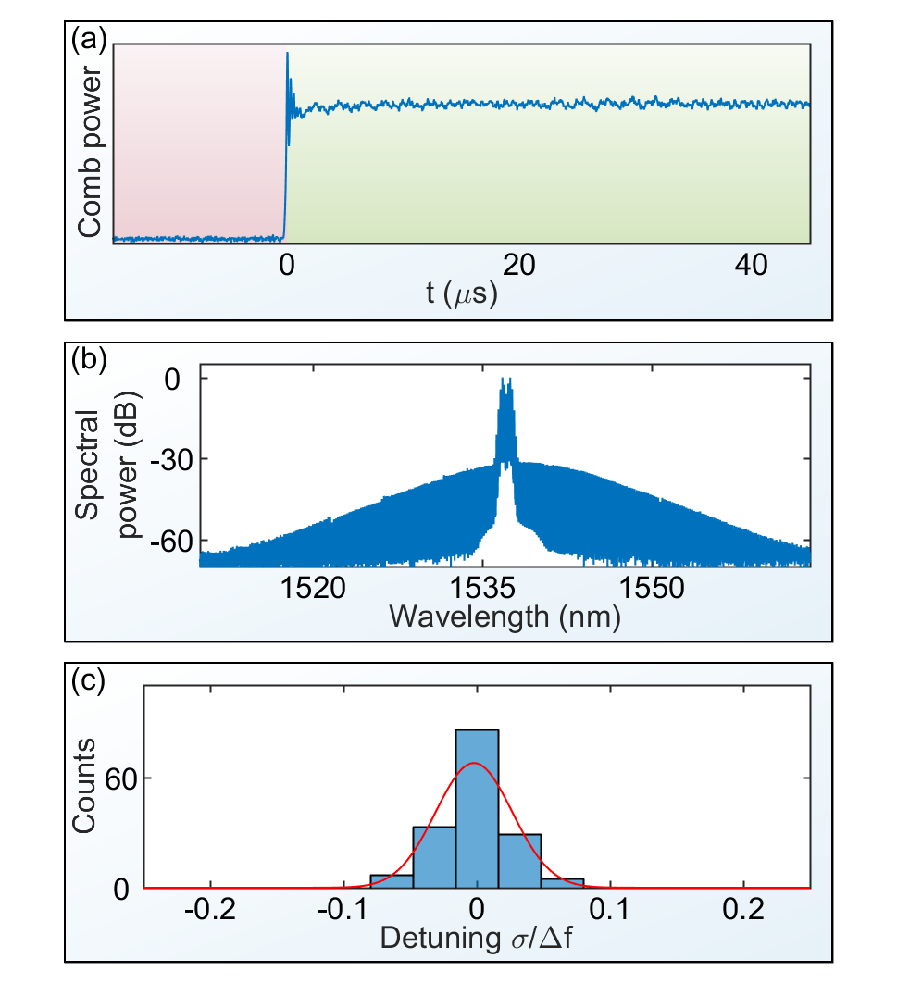

Fig. 2. (a) Measurement of a ‘reversed’ soliton step in the comb power associated with direct soliton generation from the background. (b) Measured optical spectrum of the soliton generated with a phase-modulated pump laser. The spectrum of the chirped pump laser is visible in the center. (e) Histogram of measured normalized detuning at which a soliton is generated over 160 successive trials.

~±40 kHz. In Fig. 2a, we show a measured spectrogram of $f_{rep}$ as $f_{PM}$ is swept sinusoidally over ±50 kHz. The repetition rate follows the PM except for glitches near the peaks of the sweep. In the inset of Fig. 2a we overlay the results of LLE simulations, as described below, which qualitatively match the observed behavior. These simulations indicate that the periodic nature of the glitches is due to the residual pulling of the phase modulation on the soliton when the latter periodically approaches the favored cusp of the pump’s phase profile.

In Figs. 2b and 2c we present measured eye diagrams illustrating the switching capability of $f_{rep}$ as $f_{PM}$ is switched by 80 kHz around the soliton’s natural repetition rate. In Fig. 2b, $f_{PM}$ is switched with 200 μs period and 10 μs transition time; in Fig. 2c it is switched with 100 μs period and 60 ns transition time. This data is obtained by detecting $f_{rep}$ and passing the signal through two paths, one of which contains an element that induces a frequency-dependent phase shift. From the resulting phase difference between the two paths the repetition rate can be measured in real time. These eye diagrams indicate that the PM enables exquisite control of the soliton pulse train.

We further explore the dynamics of repetition-rate switching by performing simulations of the LLE [1,10,12–14], a nonlinear partial-differential equation used to model nonlinear dynamics in Kerr ring resonators:

|  |  |  |
| --- | --- | --- |
|  |  | **(1)** |

Here $ψ$, $τ$, $α$, $F$, and $β_{2}$ are normalized quantities representing the field, time, detuning, pump field, and resonator dispersion, respectively  [12], and $θ$ is the resonator azimuthal angle in a frame co-moving at the

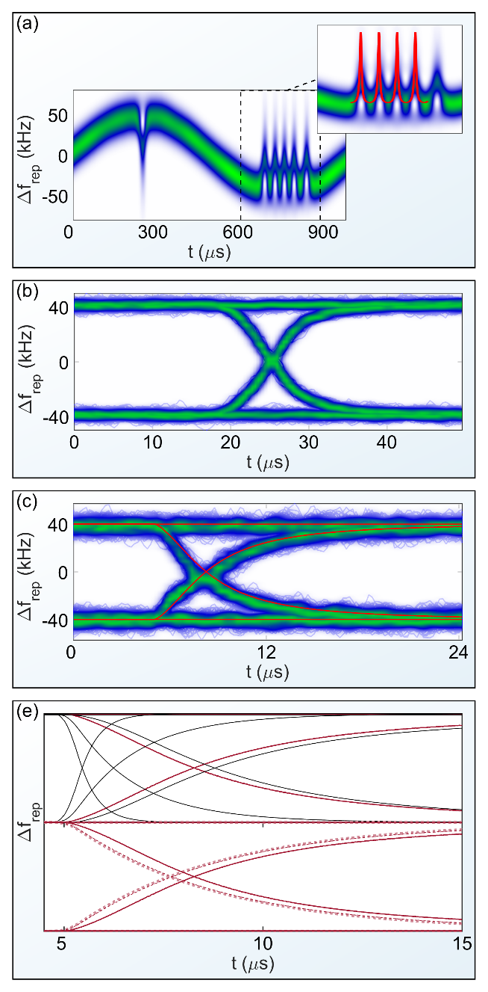

Fig. 3. (a) Measured spectrogram of $f_{rep}$ as $f_{PM}$ is swept over $±$ 50 kHz, with glitches where the locking range is exceeded. Inset: The periodic nature of the glitches agrees qualitatively with simulations of the soliton when $f_{PM}$ is outside of the locking bandwidth, shown in red. As the soliton and the phase profile of the pump evolve at different frequencies $f_{rep}$ and $f_{PM}$, the soliton periodically approaches the preferred cusp of the phase profile. The solitons group velocity changes, nearly ‘catching’ the phase modulation, before becoming clearly unlocked again. (b) Measured eye diagram of $f_{rep}$ as $f_{PM}$ is switched ±40 kHz with 10 μs transition time. (c) The same with 60 ns transition time, and an LLE simulation of the dynamics (red) with depth $δ_{PM}=$ 0.9 $π$ and resonator linewidth $Δf=$ 1.5 MHz. (d) Simulated switching dynamics for various linewidths and modulation depths. Top: $Δf=$ 10 MHz (fastest, left), 3 MHz, and 1.4 MHz (solid black). Bottom: depths of 2 $π$ and 6 $π$ (dashed red, curves nearly overlap). In each, the other parameter matches (c).

frequency $f_{PM}$. We implement the switching of $f_{PM}$ by introducing a time-varying $β_{1}=-2(FSR-f_{PM})/Δf$ term, representing a time-varying difference between the modulation frequency and the FSR of the resonator near the pump wavelength [10]. These simulations are performed using a fourth-order Runge-Kutta algorithm in the

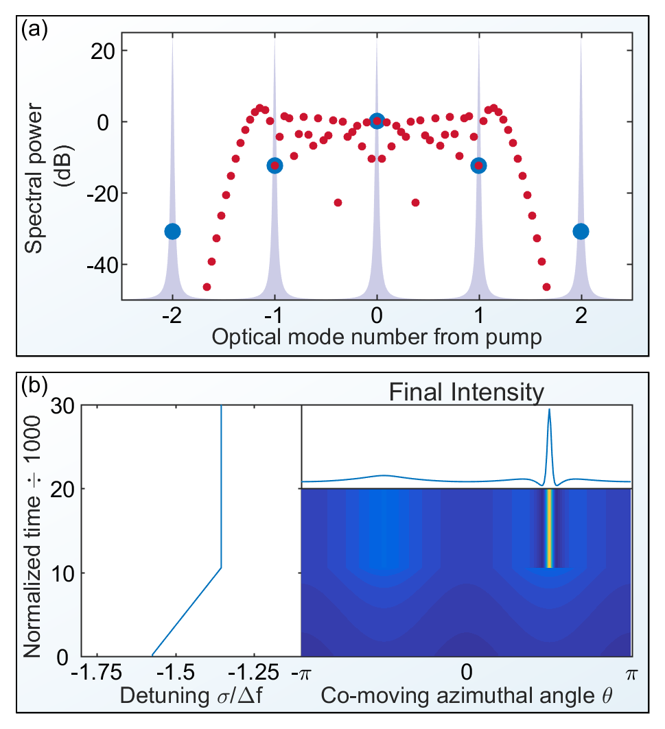

Fig. 4. (a) Spectra of phase modulation at $f_{FSR}$ with depth $0.15π$ (blue) and at $f_{FSR}/21$ with depth $\sim 8.3π$ (red). The phase and amplitude relationship between the PM sidebands that address resonator mode numbers -1, 0, and 1 (as indicated by the gray Lorentzian curves) are the same in both cases. (b) LLE simulation of single-soliton generation using the subharmonic phase-modulation spectrum shown in red in panel (a). Time is normalized to the resonator photon lifetime. Only modes $μ=0,±21,±42,…$ are coupled into the resonator and affect the LLE dynamics, with modes $\left|μ\right|>21$ having negligible power. As $Δ$ is increased from large negative detuning, a soliton is spontaneously generated, exactly as in the case of phase modulation near the FSR.

interaction picture [19] with adaptive step size [20]. In Fig. 2c we overlay a simulation of switching conducted for parameters ($Δf=$ 1.5 MHz, $δ_{PM}=$ 0.9 $π$) near the experimental values, and the agreement between measurements and simulation indicates that the measurements are consistent with fundamental LLE dynamics. We present the results of additional simulations in Fig. 2d; the basic observation is that the switching speed of $f_{rep}$ is limited by the resonator linewidth, and can be modestly improved by increasing $δ_{PM}$.

One apparent barrier to the use of a phase-modulated pump laser for protected single-soliton generation and manipulation is the fact that many microcomb resonators have FSR too high to address directly with phase modulation because of frequency limits on present electronics systems. However, it is possible to overcome this challenge by phase modulating at a subharmonic of the FSR. Our simulations indicate that PM can directly excite single solitons with low modulation depth, e.g. $δ_{PM}=0.15π$. In this limit, only the first-order PM sidebands are relevant, and their amplitude and phase relative to the carrier control the dynamics. For a small desired modulation depth defined by the relationship between the first-order sidebands and the carrier, it is possible to modulate at a frequency $\sim f_{FSR}/N$ so that the $N^{th}$-order PM sidebands and the carrier address resonator modes with relative mode numbers -1, 0, and 1. The depth of modulation at the frequency $f_{FSR}/N$ can be chosen to fix the amplitudes of the $N^{th}$-order PM sidebands relative to the carrier and target a desired effective modulation depth. In order to recover phase modulation when the PM sidebands of order $-N$, 0, and $N$ address resonator modes -1, 0, and 1, it is important that $N$ is odd; otherwise, the phase relationship between the $N^{th}$-order PM sidebands and the carrier will yield pure amplitude modulation.

In Fig. 4 we present an example of this technique. We simulate protected single-soliton generation using a pump laser modulated at $f_{mod}=f_{rep}/N=f_{rep}/21$. The effective phase-modulation depth (defined by the relationship between the 21st order PM sidebands and the carrier) is $0.15π$, and the real modulation depth at the frequency $f_{mod}$ required to achieve this value is $δ_{PM}\sim 8.3π$. Because the phase modulation spreads the optical power into the PM sidebands, use of this technique requires higher optical power to achieve the same effective pumping strength; for this specific example the optical power must be increased by ~15.6 dB. While the required modulation depth and pump power are higher with subharmonic phase modulation, neither of these numbers is impractical. This technique could be used for protected single-soliton generation in high-repetition rate systems; the example above indicates that it could be immediately applied to deterministic single-soliton generation in a 630 GHz-FSR resonator with 30 GHz phase modulation. Applying the technique with even higher repetition rates will require larger modulation depth and more optical amplification, both of which are possible and will become more practical as technology continues to develop.

In this work, we have shown that PM-pumping fundamentally changes a resonator’s excitation spectrum and accesses a new regime of protected single-soliton operation. The technique is applicable to resonators with electronically-accessible $f_{rep}$, which are important components of proposals for photonic integration of Kerr-solitons  [21,22], and can be extended to higher repetition-rate systems via subharmonic phase modulation. After soliton generation, the PM can optionally be turned off, recovering the properties of the non-PM soliton. We expect this technique to enable new experiments. For example, PM-pumped solitons are generated with known absolute timing, enabling immediate transduction of the modulation phase onto the optical pulse train; this is impossible with solitons stochastically condensed from an extended pattern. Our work brings microresonator solitons closer to applications outside the lab.

**Funding.** NASA, DARPA DODOS, NSF DGE 1144083, AFOSR FA9550-16-1-0016, and NIST.

**Acknowledgement.** We thank Su-Peng Yu and Hojoong Jung for comments on the manuscript. This work is a contribution of the US government and is not subject to copyright in the United States.

REFERENCES

1. T. Herr, V. Brasch, J. D. Jost, C. Y. Wang, N. M. Kondratiev, M. L. Gorodetsky, and T. J. Kippenberg, Nat. Photonics **8**, 145 (2014).
2. X. Yi, Q.-F. Yang, K. Y. Yang, M.-G. Suh, and K. Vahala, Optica **2**, 1078 (2015).
3. D. C. Cole, E. S. Lamb, P. Del’Haye, S. A. Diddams, and S. B. Papp, Nat. Photonics **11**, 671 (2017).
4. X. Xue, Y. Xuan, Y. Liu, P.-H. Wang, S. Chen, J. Wang, D. E. Leaird, M. Qi, and A. M. Weiner, Nat Phot. **9**, 594 (2015).
5. K. Luo, J. K. Jang, S. Coen, S. G. Murdoch, and M. Erkintalo, Opt. Lett. **40**, 3735 (2015).
6. C. Joshi, J. K. Jang, K. Luke, X. Ji, S. A. Miller, A. Klenner, Y. Okawachi, M. Lipson, and A. L. Gaeta, Opt. Lett. **41**, 2565 (2016).
7. H. Guo, M. Karpov, E. Lucas, A. Kordts, M. H. P. Pfeiffer, V. Brasch, G. Lihachev, V. E. Lobanov, M. L. Gorodetsky, and T. J. Kippenberg, Nat. Phys. **13**, 94 (2017).
8. V. E. Lobanov, G. V. Lihachev, N. G. Pavlov, A. V. Cherenkov, T. J. Kippenberg, and M. L. Gorodetsky, Opt. Express **24**, 27382 (2016).
9. S. B. Papp, K. Beha, P. Del’Haye, F. Quinlan, H. Lee, K. J. Vahala, and S. A. Diddams, Optica **1**, 10 (2014).
10. H. Taheri, A. A. Eftekhar, K. Wiesenfeld, and A. Adibi, IEEE Photonics J. **7**, 2200309 (2015).
11. J. K. Jang, M. Erkintalo, S. G. Murdoch, and S. Coen, Opt. Lett. **40**, 4755–4758 (2015).
12. Y. K. Chembo and C. R. Menyuk, Phys. Rev. A **87**, 53852 (2013).
13. S. Coen, H. G. Randle, T. Sylvestre, and M. Erkintalo, Opt. Lett. **38**, 37–39 (2013).
14. C. Godey, I. V. Balakireva, A. Coillet, and Y. K. Chembo, Phys. Rev. A **89**, 63814 (2014).
15. J. K. Jang, M. Erkintalo, S. Coen, and S. G. Murdoch, Nat. Commun. **6**, 7370 (2015).
16. H. Lee, T. Chen, J. Li, K. Y. Yang, S. Jeon, O. Painter, and K. J. Vahala, Nat. Photonics **6**, 369 (2012).
17. T. Carmon, L. Yang, and K. J. Vahala, Opt. Express **12**, 4742 (2004).
18. J. R. Stone, T. C. Briles, T. E. Drake, D. T. Spencer, D. R. Carlson, S. A. Diddams, and S. B. Papp, arXiv 1708.08405 (2017).
19. J. Hult, J. Light. Technol. **25**, 3770 (2007).
20. A. M. Heidt, J. Light. Technol. **27**, 3984 (2009).
21. D. T. Spencer, T. Drake, T. C. Briles, J. Stone, L. C. Sinclair, C. Fredrick, Q. Li, D. Westly, B. R. Ilic, A. Bluestone, N. Volet, T. Komljenovic, L. Chang, S. H. Lee, D. Y. Oh, M. Suh, K. Y. Yang, M. H. P. Pfeiffer, J. Tobias, E. Norberg, L. Theogarajan, K. Vahala, N. R. Newbury, K. Srinivasan, J. E. Bowers, S. A. Diddams, and S. B. Papp, arXiv 1708.05228 (2017).
22. T. C. Briles, J. R. Stone, T. E. Drake, D. T. Spencer, C. Frederick, Q. Li, D. A. Westly, B. R. Illic, K. Srinivasan, S. A. Diddams, and S. B. Papp, arXiv 1711.06251 (2017).

Full reference list

1. T. Herr, V. Brasch, J. D. Jost, C. Y. Wang, N. M. Kondratiev, M. L. Gorodetsky, and T. J. Kippenberg, "Temporal solitons in optical microresonators," Nat. Photonics **8**, 145–152 (2014).

2. X. Yi, Q.-F. Yang, K. Y. Yang, M.-G. Suh, and K. Vahala, "Soliton frequency comb at microwave rates in a high-Q silica microresonator," Optica **2**, 1078–1085 (2015).

3. D. C. Cole, E. S. Lamb, P. Del’Haye, S. A. Diddams, and S. B. Papp, "Soliton crystals in Kerr resonators," Nat. Photonics **11**, 671–676 (2017).

4. X. Xue, Y. Xuan, Y. Liu, P.-H. Wang, S. Chen, J. Wang, D. E. Leaird, M. Qi, and A. M. Weiner, "Mode-locked dark pulse Kerr combs in normal-dispersion microresonators," Nat Phot. **9**, 594–600 (2015).

5. K. Luo, J. K. Jang, S. Coen, S. G. Murdoch, and M. Erkintalo, "Spontaneous creation and annihilation of temporal cavity solitons in a coherently driven passive fiber resonator," Opt. Lett. **40**, 3735–3738 (2015).

6. C. Joshi, J. K. Jang, K. Luke, X. Ji, S. A. Miller, A. Klenner, Y. Okawachi, M. Lipson, and A. L. Gaeta, "Thermally controlled comb generation and soliton modelocking in microresonators," Opt. Lett. **41**, 2565–2568 (2016).

7. H. Guo, M. Karpov, E. Lucas, A. Kordts, M. H. P. Pfeiffer, V. Brasch, G. Lihachev, V. E. Lobanov, M. L. Gorodetsky, and T. J. Kippenberg, "Universal dynamics and deterministic switching of dissipative Kerr solitons in optical microresonators," Nat. Phys. **13**, 94–102 (2017).

8. V. E. Lobanov, G. V. Lihachev, N. G. Pavlov, A. V. Cherenkov, T. J. Kippenberg, and M. L. Gorodetsky, "Harmonization of chaos into a soliton in Kerr frequency combs," Opt. Express **24**, 27382 (2016).

9. S. B. Papp, K. Beha, P. Del’Haye, F. Quinlan, H. Lee, K. J. Vahala, and S. A. Diddams, "Microresonator frequency comb optical clock," Optica **1**, 10–14 (2014).

10. H. Taheri, A. A. Eftekhar, K. Wiesenfeld, and A. Adibi, "Soliton formation in whispering-gallery-mode resonators via input phase modulation," IEEE Photonics J. **7**, 2200309 (2015).

11. J. K. Jang, M. Erkintalo, S. G. Murdoch, and S. Coen, "Writing and erasing of temporal cavity solitons by direct phase modulation of the cavity driving field," Opt. Lett. **40**, 4755–4758 (2015).

12. Y. K. Chembo and C. R. Menyuk, "Spatiotemporal Lugiato-Lefever formalism for Kerr-comb generation in whispering-gallery-mode resonators," Phys. Rev. A **87**, 53852 (2013).

13. S. Coen, H. G. Randle, T. Sylvestre, and M. Erkintalo, "Modeling of octave-spanning Kerr frequency combs using a generalized mean-field Lugiato-Lefever model," Opt. Lett. **38**, 37–39 (2013).

14. C. Godey, I. V. Balakireva, A. Coillet, and Y. K. Chembo, "Stability analysis of the spatiotemporal Lugiato-Lefever model for Kerr optical frequency combs in the anomalous and normal dispersion regimes," Phys. Rev. A **89**, 63814 (2014).

15. J. K. Jang, M. Erkintalo, S. Coen, and S. G. Murdoch, "Temporal tweezing of light through the trapping and manipulation of temporal cavity solitons," Nat. Commun. **6**, 7370 (2015).

16. H. Lee, T. Chen, J. Li, K. Y. Yang, S. Jeon, O. Painter, and K. J. Vahala, "Chemically etched ultrahigh-Q wedge-resonator on a silicon chip," Nat. Photonics **6**, 369–373 (2012).

17. T. Carmon, L. Yang, and K. J. Vahala, "Dynamical thermal behavior and thermal self-stability of microcavities," Opt. Express **12**, 4742–4750 (2004).

18. J. R. Stone, T. C. Briles, T. E. Drake, D. T. Spencer, D. R. Carlson, S. A. Diddams, and S. B. Papp, "Thermal and Nonlinear Dissipative-Soliton Dynamics in Kerr Microresonator Frequency Combs," arXiv 1708.08405 (2017).

19. J. Hult, "A Fourth-Order Runge-Kutta in the Interaction Picture Method for Simulating Supercontinuum Generation in Optical Fibers," J. Light. Technol. **25**, 3770–3775 (2007).

20. A. M. Heidt, "Efficient Adaptive Step Size Method for the Simulation of Supercontinuum Generation in Optical Fibers," J. Light. Technol. **27**, 3984–3991 (2009).

21. D. T. Spencer, T. Drake, T. C. Briles, J. Stone, L. C. Sinclair, C. Fredrick, Q. Li, D. Westly, B. R. Ilic, A. Bluestone, N. Volet, T. Komljenovic, L. Chang, S. H. Lee, D. Y. Oh, M. Suh, K. Y. Yang, M. H. P. Pfeiffer, J. Tobias, E. Norberg, L. Theogarajan, K. Vahala, N. R. Newbury, K. Srinivasan, J. E. Bowers, S. A. Diddams, and S. B. Papp, "An Integrated-Photonics Optical-Frequency Synthesizer," arXiv 1708.05228 (2017).

22. T. C. Briles, J. R. Stone, T. E. Drake, D. T. Spencer, C. Frederick, Q. Li, D. A. Westly, B. R. Illic, K. Srinivasan, S. A. Diddams, and S. B. Papp, "Kerr-microresonator solitons for accurate carrier-envelope-frequency stabilization," arXiv 1711.06251 (2017).